Handwriting policy
At Ormiston Meadows Academy we intended to provide a clear framework for a shared understanding of teaching handwriting and ensuring continuity across the school.
We want all children to be able to write fluidly and with correct formation of letters to ensure they become confident and capable writers.
Children will be taught the skills of handwriting, following the scheme, at least twice a week for 15 mins. If they are grasping skills in line with expectations, then they should apply these skills in all writing they complete.
If children are not making the expected amounts of progress, they will have additional time outside of the handwriting sessions to close the gap with their peers. These sessions should be supported by an adult.
Using Penpals
There are 5 stages within the scheme:
1. Readiness for writing: gross and fine motor skills leading to letter formation (Foundation Stage-Nursery and Reception) This links closely with our use on RWI.
2. Beginning to join (Lower KS1- Yr1 and 2)
3. Securing joins (Upper KS1/Lower KS2- Y2 and Y3)
4. Practising speed and fluency (Lower KS2- Y3 and Y4)
5. Presentation skills (Upper KS2- Y5 and Y6
Basics
Posture and pencil grip are taught alongside the skills above. Children should be taught to use a tripod grip, Children should be shown how to place their pencil on the table in front of them with it pointing towards their bodies and to then pick it up and allow the pencil to fall back into the tripod grip.
Joining and not joining
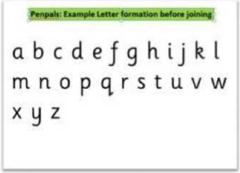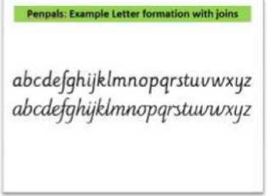

Handwriting teaching in the Early Years Foundation Stage
In the Foundation Stage children need to develop skills which will later enable them to acquire a legible, fluent and fast handwriting style. In nursery and reception children will develop:
− Gross and fine motor skills through sensory activities
− Recognition of pattern and language to talk about shapes and movement e.g. forming shapes and letters in sand/ shaving foam
− Shaping of patterns and basic letter movements
− A comfortable tripod pencil grip (between the thumb and forefinger with the pencil resting on the third finger) that allows for efficient control of the pencil
− Correct formation of all lower case letters (taught through Read Write Inc. Phonics)

Teaching Handwriting in Key Stage 1 and 2
The highest priority is given to teaching the correct letter formation before any attempt is made at joining.
Key Stage 1 Children will continue to develop fine and gross motor-skills with a range of multi-sensory activities. Teachers and support staff continue to guide children on correct letter formation using a comfortable tripod pencil grip that allows for efficient control. Through the Penpals scheme children will begin to learn how to join letters in Year 1 and continue to practice this skill in Year 2.
Key Stage 2 Children will continue to have regular practice of handwriting, securing the joins and developing speed and fluency. By the end of Year 6 pupils should have a clear, fluid handwriting style. Children will have the opportunity to earn a ‘pen licence’ from Year 3 upwards and may use a handwriting pen rather than pencil at the discretion of the teacher.

Handwriting feedback and assessment
This will take place in the lesson, teachers and other adults should be using ‘live marking’ to ensure children are not leaving the lessons with misconceptions.
Termly assessment will take place and QLA will take place, this will inform teaching of the class and small groups to ensure rapid and sustained progress for all children.
Inclusion
Where children are not making progress in line with their peers additional support will be put in place during the school day to support handwriting.
There may be times where there are significant delays and SENCO or Occupational Therapist advice may need to be sought.
Left handed pupils (approximately 10% of the population) are supported by being encouraged to: − Turn their paper to the right rather than the left − Sit on the left hand side of a right handed child so they have enough space − Position their keep the wrist straight and their hand below the writing line

