Maths at Ormiston Meadows Academy
Planning | Outcome | Expectation/ Evidence | How to use it
Long Term Plans | All units within the maths curriculum will be covered – outlined on the Long Term Plan. | Ensure each unit is taught in the order as outlined on the Long Term Plan.  If you wish to move units about, discuss with the maths lead before doing so. | - Follow carefully.  - Check before starting a new unit to ensure you are starting the correct one.
Medium Term Plans | All objectives will be covered in every year group, as outlined on the medium term plan.  Teachers will have sufficient time to teach objectives to a mastery lesson (White Rose supports with this). | Teachers will use the Medium Term Plan and White Rose to know how long each unit will last – if more or less time is needed for each unit, teachers will use their judgement to move at a pace suitable to the class.  National Curriculum objectives are explicitly stated.  EYFS Early Learning Goals explicitly stated. | - All objectives must be taught in each unit.  - Time stated for each unit isn’t strict – it should be taught until you feel each child has reached appropriate levels in learning.  - Teachers can use White Rose to support their planning.  - The school calculation policy must be used in teaching any calculation units.
Short Term Plans | All staff will have a weekly plan with core objectives from the Medium Term Plan’s covered.  All pupils will make progress in each lesson.  All staff will use the same outline for their maths lessons. | Staff will use their own lesson plan format or plan using power points.  - These will always include key objectives being covered that week and any other detail that the teacher feels they need to teach effectively.  Vocabulary will be explicitly stated on the plan/ PowerPoint.  All staff to follow the same outline:  - maths meeting  - introduce vocabulary and learning outcomes  - teaching new skill/ modelling  - guided practice  - independent practice
Calculation Policy | Staff have a clear idea of the progression of teaching the four operations.  Pupils are taught using the concrete, pictorial and abstract representations, ensuring they have a deep understanding of the underlying mathematical concepts.  Models how to use resources for staff.  The calculations on the policy are a progression rather than a yearly doc so staff can identify which skill is a gap. | Teachers will use the concrete-pictorial-abstract approach to ensure pupils have a deep understanding, proficiency of strategies and move towards mastering content.  Teachers will use the calculation policy when planning to see the appropriate breakdown of each skill.  Representations will be captured and shown on the Maths working wall during the topic – children can refer to it at any time to support thinking  Book looks will demonstrate if appropriate strategies have been used by children | 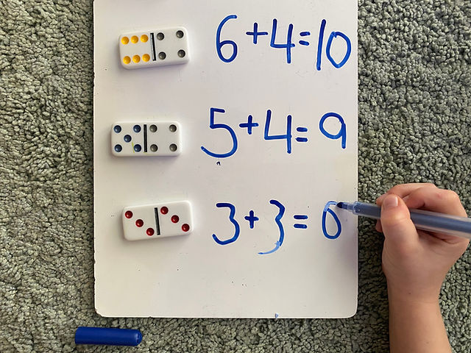  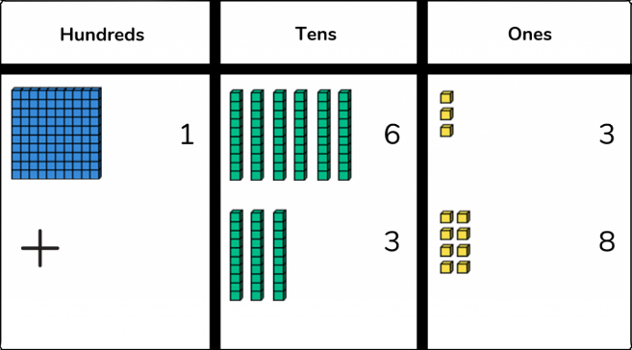
Teaching and learning | Outcome | Expectation/ Evidence | How to use it
Maths Meetings | Children will develop fluency and pace at recalling key mathematical facts.  Children will hear, share and use improved mathematical vocabulary.  As topics are covered in a mastery curriculum, key concepts will be revisited constantly to embed and ensure mastery.  EYFS maths meeting 5 minutes, revisiting prior learning. | A 10 minute session requiring fast pace.  It should involve active approaches (songs, actions, pictures, chants, real life contexts).  It should be taught as a whole class – differentiated through questioning.  Questions should be asked using a hands down approach.  Adults should model reasoning and children are to answer in full sentences – modelled constantly by adults.  Lots of partner talk to encourage discussion.  One slide dedicated to one times table each week, either practicing a times table or skip counting using different and fun approaches.  Only verbal responses are required in sessions, there should be no evidence in books. | - TAs to take notes of pupil comments for assessment.  - TA to use this time for immediate intervention.  - Pictures could be used to aid the children’s understanding.  - Pre-teaching/ learning
Key Facts/ Times tables | All pupils will know all times table facts up to 12 x 12 by the end of Year 4.  All pupils will have daily times table/ skip counting practice.  All pupils will know the number bonds to 20 by the end of Year 2. | Various strategies used to teach times table facts (songs, games, chanting etc.)  1 slide will cover times table facts in each daily maths meeting.  All KS2 pupils will complete a times table test once a week.  Year 2-6 children will have regular practice on TT Rock Stars to practice their times tables. | - Use different strategies to teach/ practice the times table (songs, games, chanting etc.)  - Display times table facts in the classroom.  - Homework given on relevant times tables.  - Ensure children are accessing garage on TT Rock Stars.
Daily lesson | Each class will have 4 maths lessons, lasting 75 minutes (including at least 10 minutes for maths meeting).  Throughout the year, maths lessons will cover all national curriculum objectives.  Maths lessons will be planned following the medium term planning documents, including White Rose. | Share the learning objective for the lesson – this will be stuck in each child’s book (KS1 and KS2).  Expose children to relevant vocabulary for the lesson.  Concrete, pictorial and abstract representations are used to teach and model teaching calculations (as seen in the calculation policy).  All pupils will have access to resources (bead strings, place value counters, dienes etc.) during maths lessons.  Formative assessment will take place in every maths lesson to ensure all pupils are making progress.  Mastery will be embedded into every maths lesson.  There will be challenge and high expectations for all learners in every lesson, a follow up challenge will not always be given if the work itself is challenging.  Questioning will be used throughout every lesson.  EYFS have a daily lesson, a guided input where new learning is introduced and taught and then continuous provision in class throughout the school day/ week linked to the objective (s) being taught that week. | - All lessons should be prepared and planned for in advance.  - Objectives and lesson plans/ resources should be shared with any other adults that work in the classroom, giving them enough time to prepare.  - Daily lessons should take into account learning from each child the previous session. Changes to future days planning can be hand written onto lesson plans.  - Children should show progression during each daily session.  - All adults working with guided groups should be making notes of each child’s learning that session.  - Learning can be recorded as written calculations in books, photographs or orally and/or using whiteboards if working as part of a guided group.
Learning objective | Every lesson will have a learning objective which will allow show what the children are learning.  The learning objective is an assessment tool that allows each teacher to quantify their impact on student achievement. | Learning objective for every lesson – KS1 and KS2.  Every learning objective will show whether concrete, pictorial or abstract has been used in the lesson. | 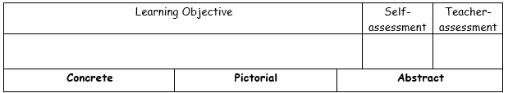
Environment and Resources | There should be a maths working wall in every classroom.  Maths resources should be accessible to all pupils in the class.  Whole school maths resources should be stored in the maths area in your class or in the maths area. | Every classroom will have a maths working wall which will include:  - Key objectives for the unit of work  - Key vocabulary for the unit of work  - Examples of concrete, pictorial and abstract images.  - Examples fluency and variation (calculation policy)  Every classroom will have access to maths resources to support concrete and pictorial representations.  Examples of maths will be seen in Science and other non-core subject displays. | 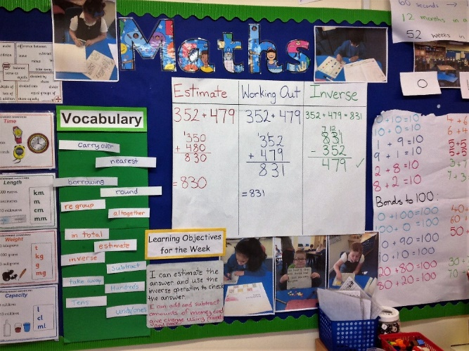
Homework | Weekly homework will be given to all pupils KS2 pupils and set accordingly for KS1. | All pupils in KS2 will be set maths homework using TT Rock Stars.  Additional maths homework may be set linked to the learning that week.  Appropriate homework can be chosen by the class teacher. | - Teachers to ensure all pupils have a login and are given their login details at the beginning of the year for TT Rockstars.  - Homework set weekly related to learning in class.
Marking | All pupils work will be marked regularly using verbal feedback.  Marking will give advice and feedback and move learning forwards. | Pupils work will be marked according to the Academy feedback and assessment policy.  The teacher will assess whether the children have achieved the learning objective on it, for example using arrows.  Children will self-assess the learning from the lesson on their learning objective.
Assessment | All objectives will be assessed by teachers (formative).  Maths (PiXL) tests will be administered three times a year – Year 2 – 6. The QLAs will be used to inform teaching and interventions.  PiXL therapies will be used to fill gaps in knowledge. | AFL should take place throughout each lesson. Notes from guided group work should be recorded.  Pupils should be taught and encouraged to self and peer assess during lessons and (in KS2) record this on learning objective slips.  Pupils learning will be assessed daily and planning adapted accordingly.  Testing (PiXL tests) of maths skills will take place in November, March (Year 2-6) and June (Year 1-6) and analysed by OAT data team.  All children will complete an end of unit assessment to inform teachers planning and interventions.  All teachers will have half termly pupil progress meetings to analyse progress and attainment of all pupils in their class.  EYFS complete a Baseline Assessment in Autumn 1 and the EYFS profile assessment in the Summer term. | 