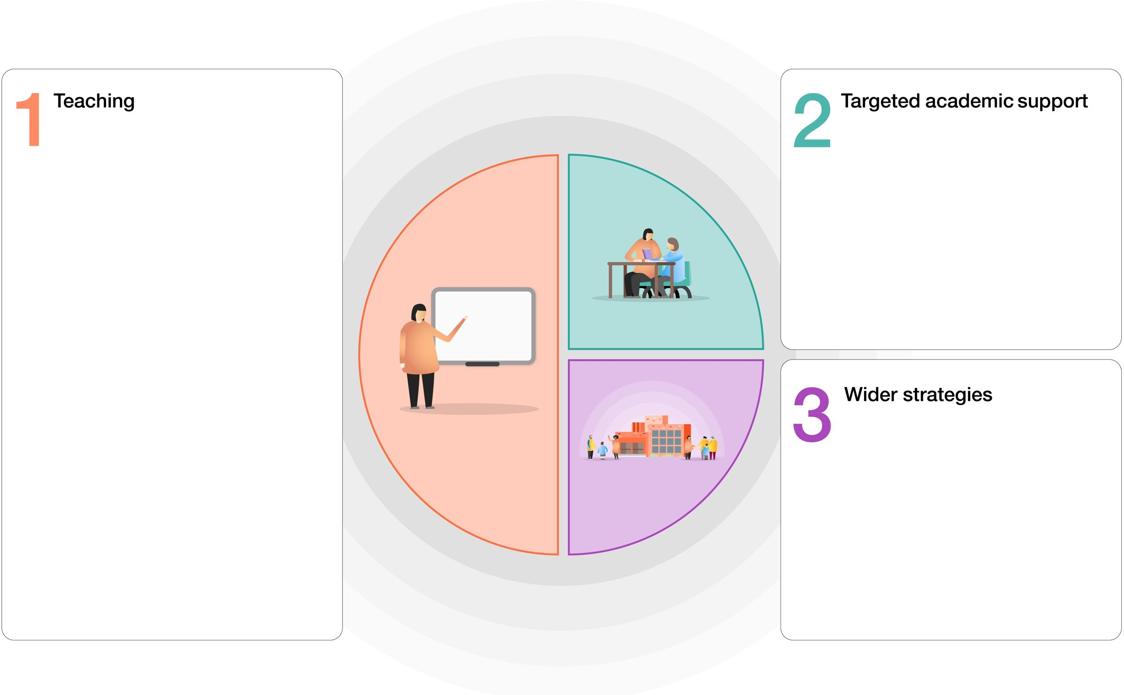
Ormiston Meadows Academy

Quality first teaching supported by
additional CPD for teachers, and regular CPD for support staff.
Booster support for Key Marginal Pupils in maths and English.
Provision to close gaps due to Covid
Restrictions to be prioritised across all year groups.
Rigorous and methodical approach to
teaching of basic skills: number bonds/
times tables/phonics/grammar.
Emphasis on reading culture; reading for pleasure whole school approach, guided reading strategies, use of Lexia.
Focus on Writing in all year groups.
Developing staff in teaching to Mastery to increase challenge for all.
Whole school implementation of core values to develop learning strategies.

Half-termly pupil progress meetings to include specific discussions for identified pupils, with clear actions.
Targeted group teaching in Year 6.
Bespoke interventions where required based on Pixl therapies or evidence-based interventions across all year groups.

Working with parents to support children’s
Learning
Links with external strategies such as National Literacy Project in support reading at home and school
Wide range of visitors, visits and clubs.
Support for pupils and families to reduce persistent absence.

